Unreal plugin getting started document.

This document assumes unreal 5.0.x as baseline, but these steps are also applicable on 4.25, 4.26, 4.27 and 5.1.

# Installing plugin

In order to add a plugin you would need to add the downloaded plugin to Unreal’s Plugin folder.

So, for default installation path navigate to Program Files > Epic Games > 5.0 > Engine > Plugins, and add the plugins folder there.

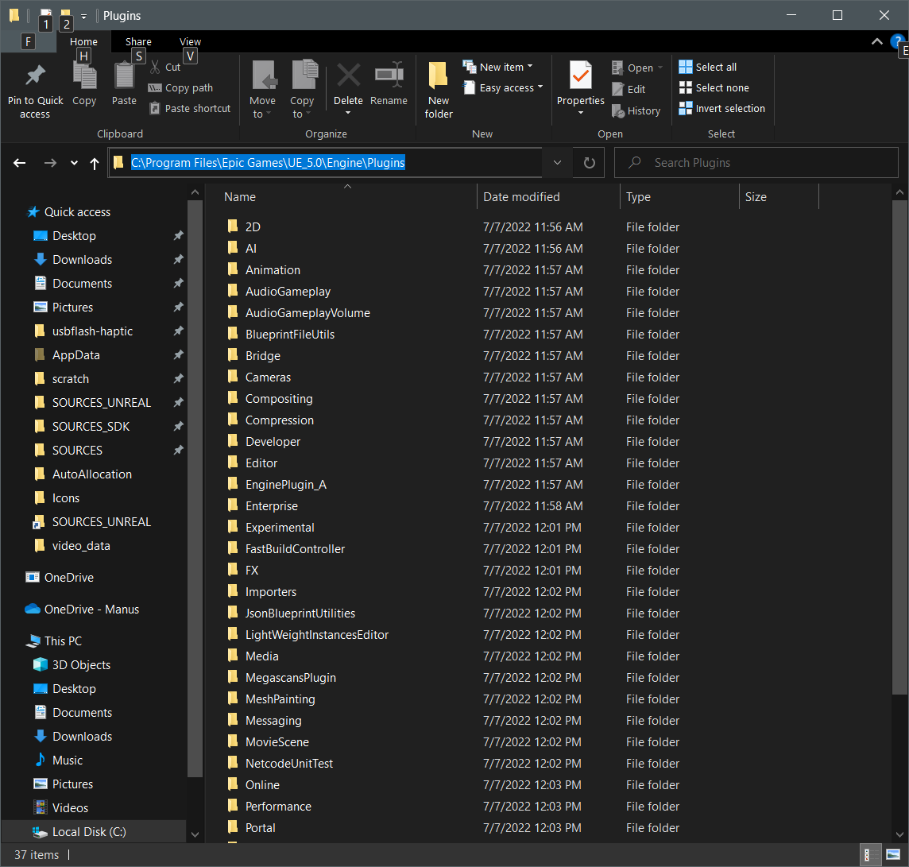

If there is no folder Create a new one and put the files in there. This will add the plugin to that version of the engine.

Now, launch a project in 5.0. Go to Edit > Plugins > " The plugin that you added" > and in that section make sure the Enabled check box is checked on."

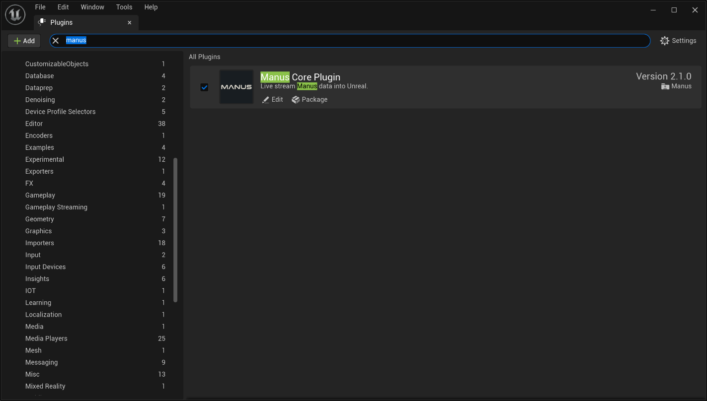

# Starting unreal with plugin

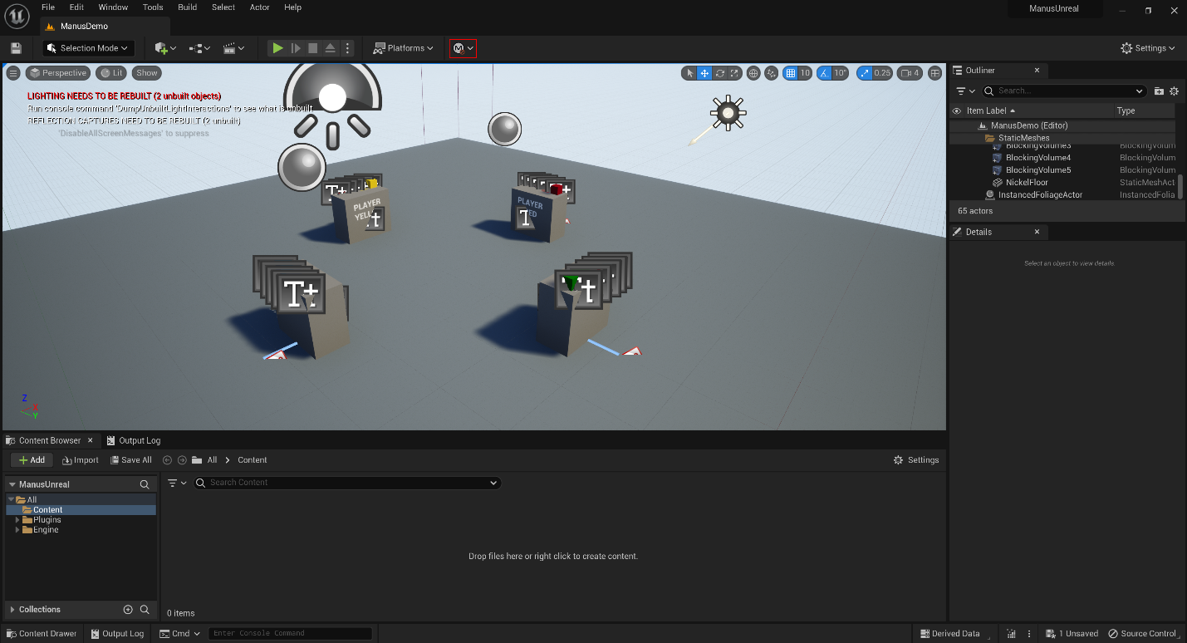

## Connect

By default there is no connection and the localhost is pre-selected.

If you press this button it will reveal a drop down menu of all detected manus core instances.



The currently selected option is marked with the green connect icon.

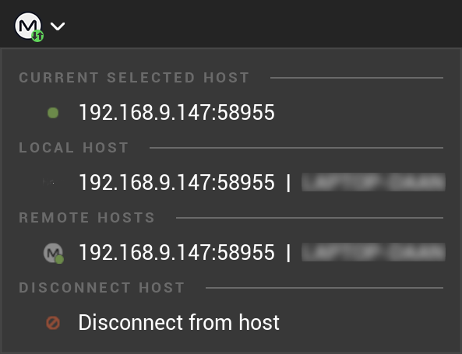

Once connected to your Manus core host of choice the icon will be shown as green, you can then get runtime data of your gloves and more.



If you press it again you can choose to disconnect from the host and connect to another.



Quite a few functions are unavailable when disconnected.

## Refresh host list

When you want to refresh to detected hosts in the host selection dropdown, you can press this button.



It will scan the network for any Manus core active at that time and update it in the host selection list.

# Setting up a model to animate

Some of these steps, like importing a model, are detailed only lightly as they are explained better in Unreal specific tutorials.

Import model

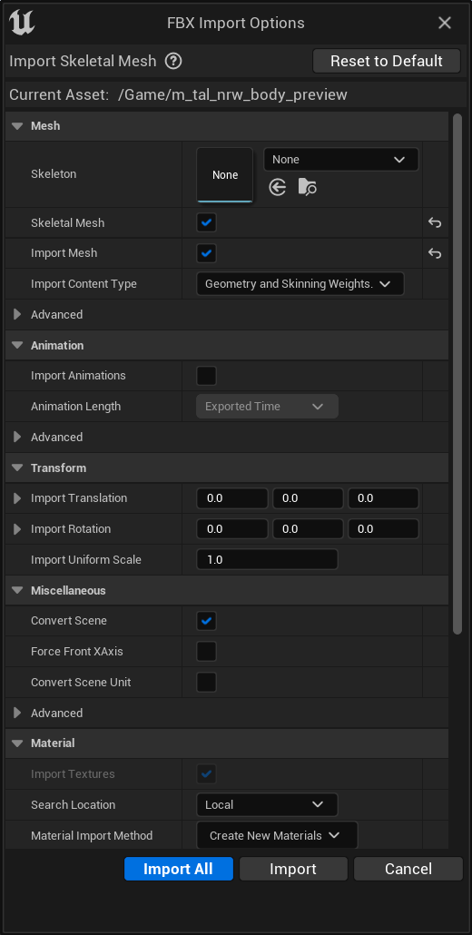

After importing your model you will have something similar to the following in your content directory:

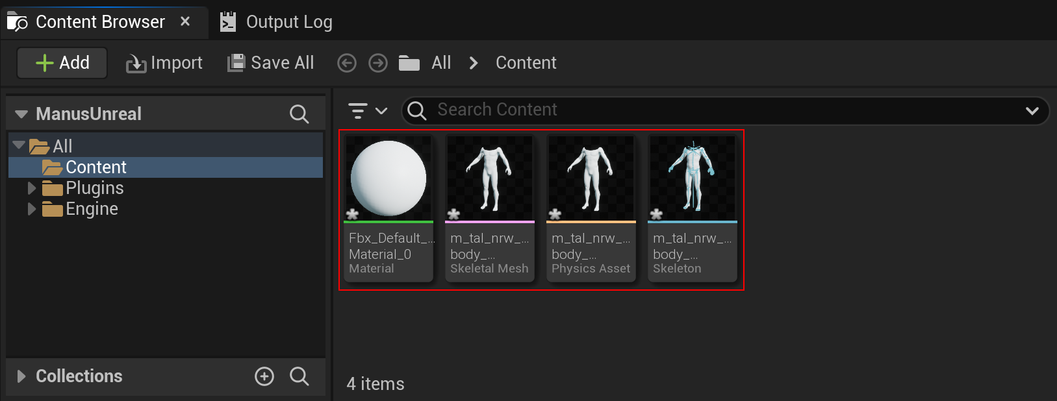

You now right click the skeleton mesh and create a new animation blueprint

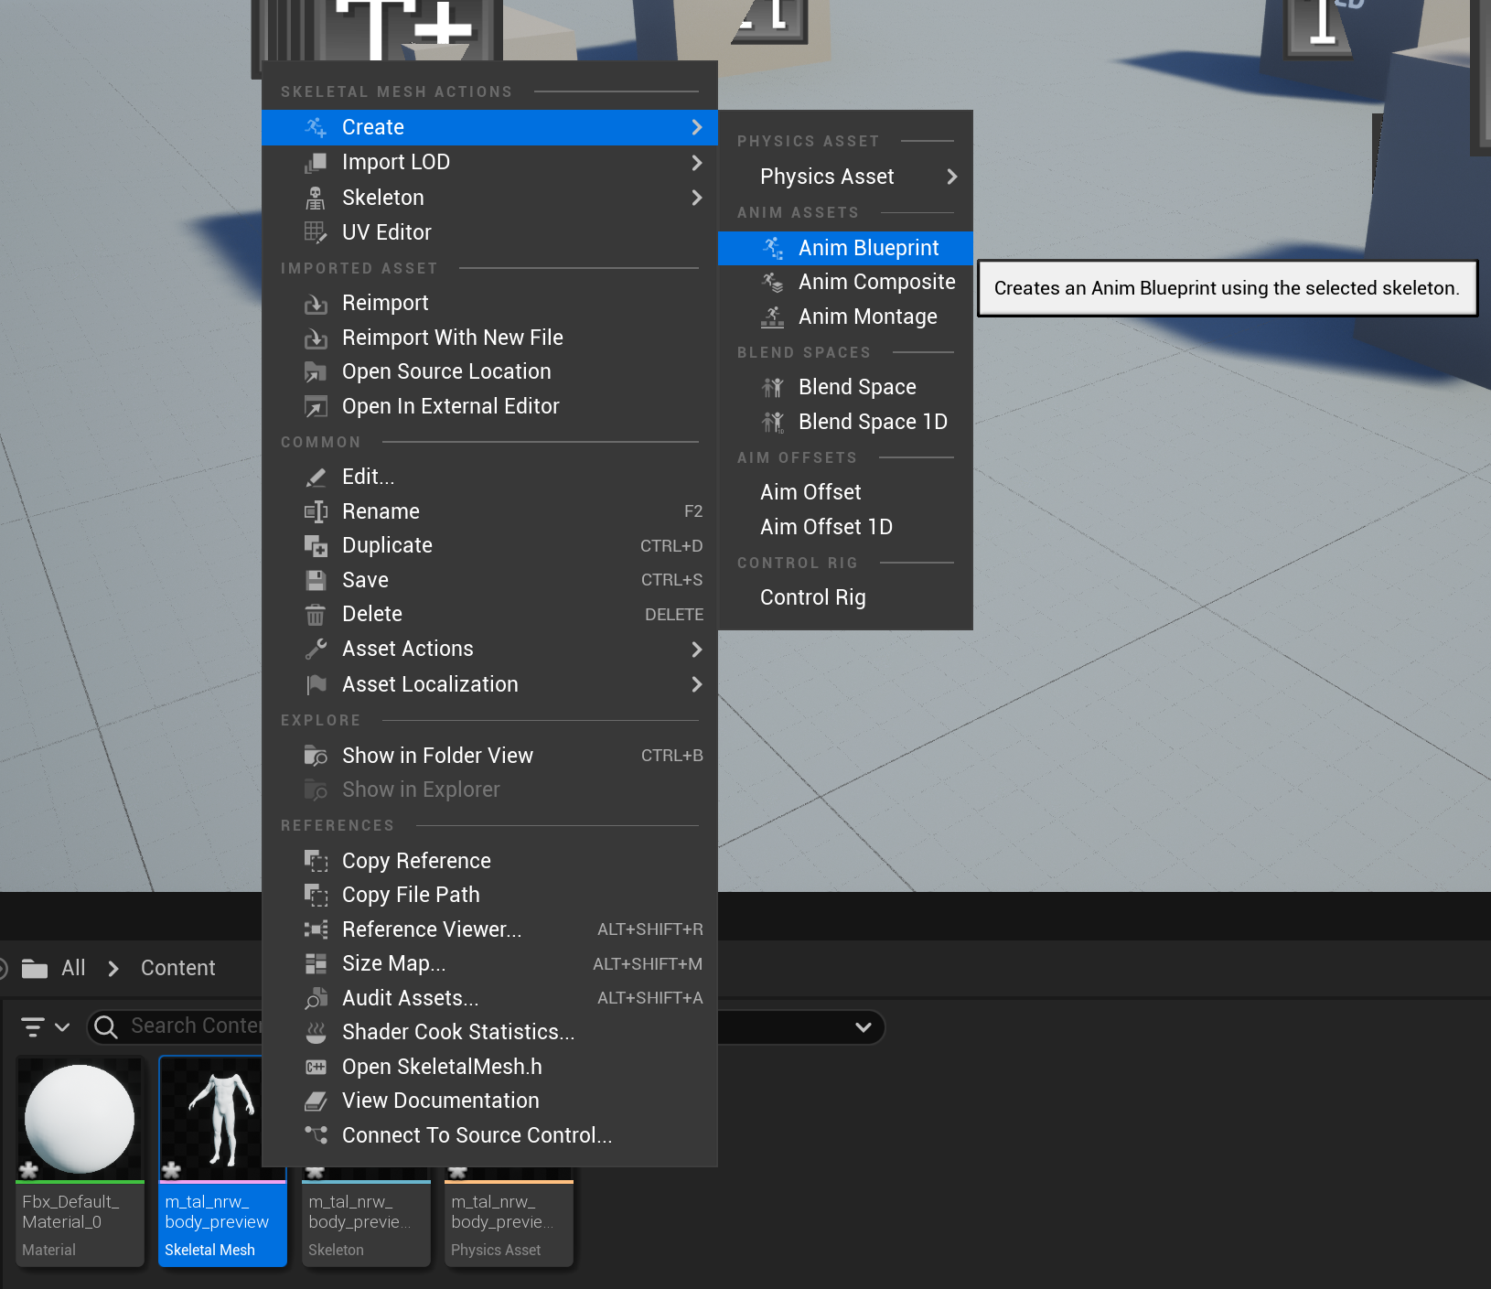

Give the animation blueprint a nice name and double click it to open it.

You will be presented with a screen similar to this, but for your specific model.

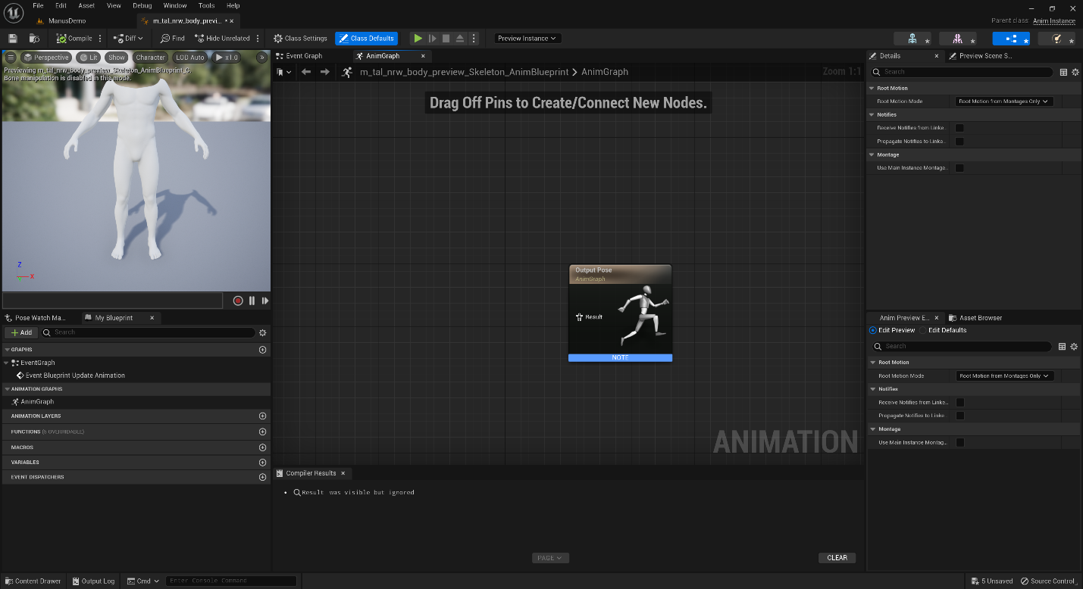

In the output post widget drag the Result to the left and select the “Manus Live Link Pose”

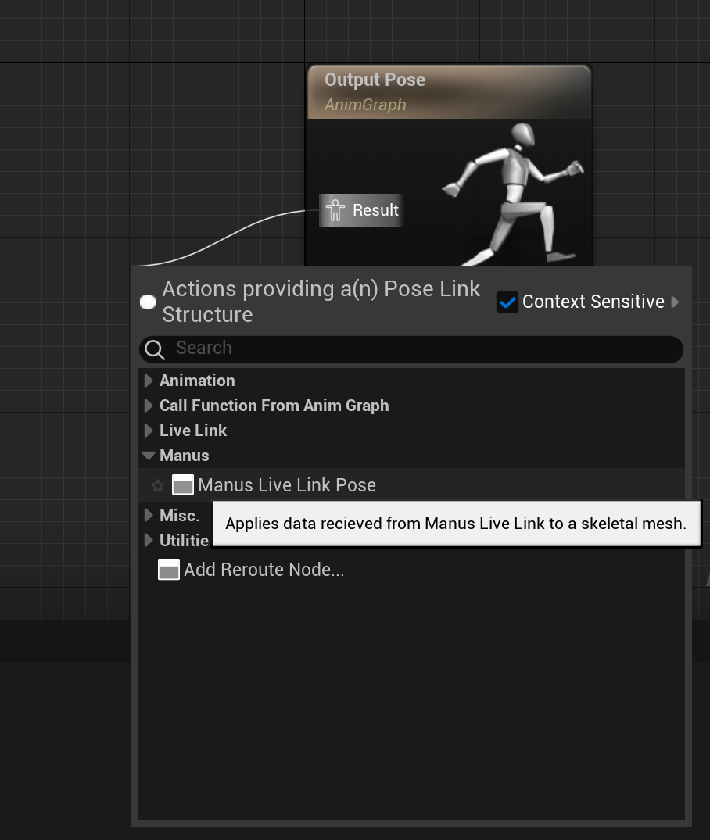

From here select the “Manus Live Link Pose” widget and go to the properties on the right side.

There select the manus skeleton drop down box and create a new asset “Manus Skeleton” and give it a nice name. In this example “ManusBody” is used.

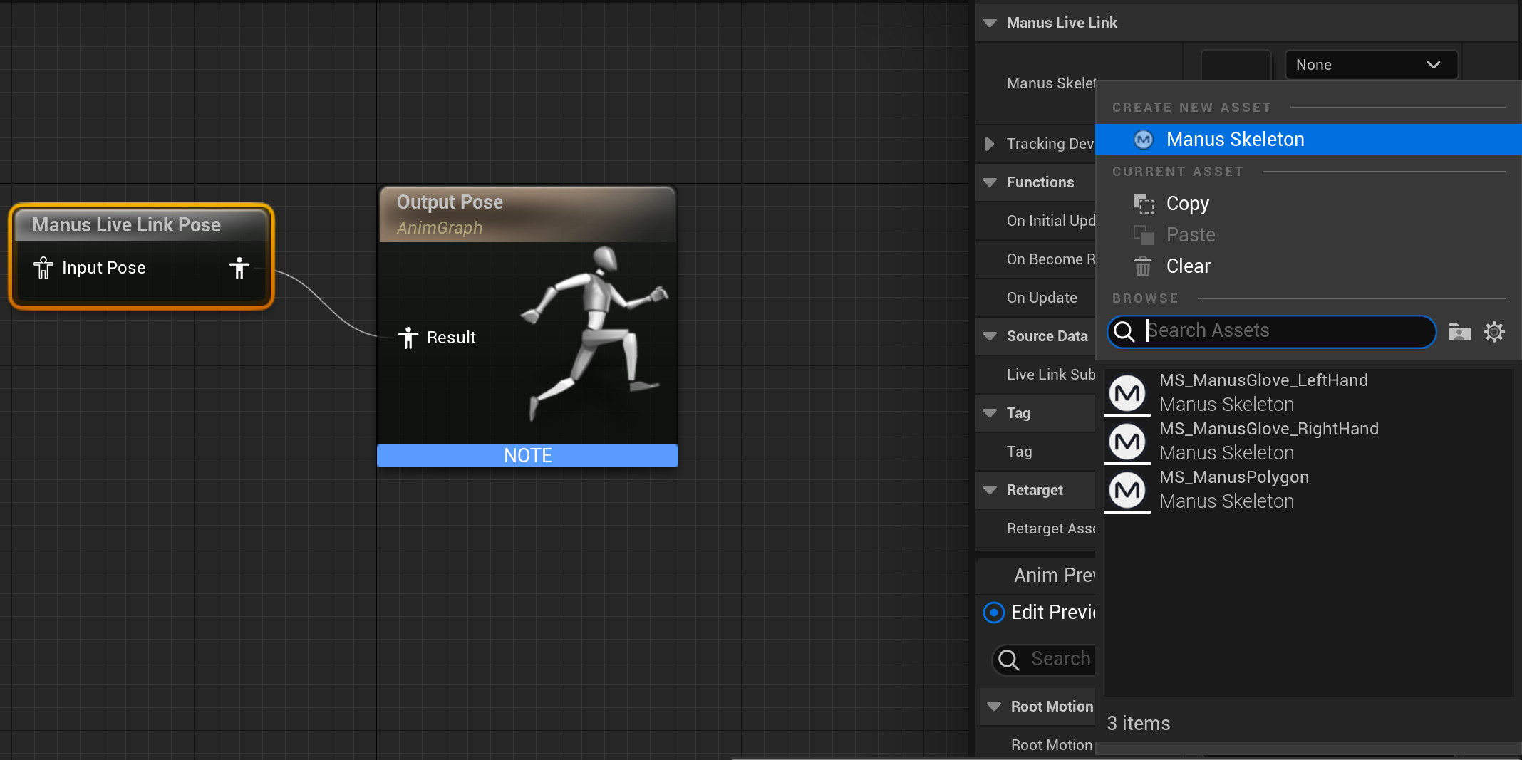

Don’t forget to compile the blueprint.

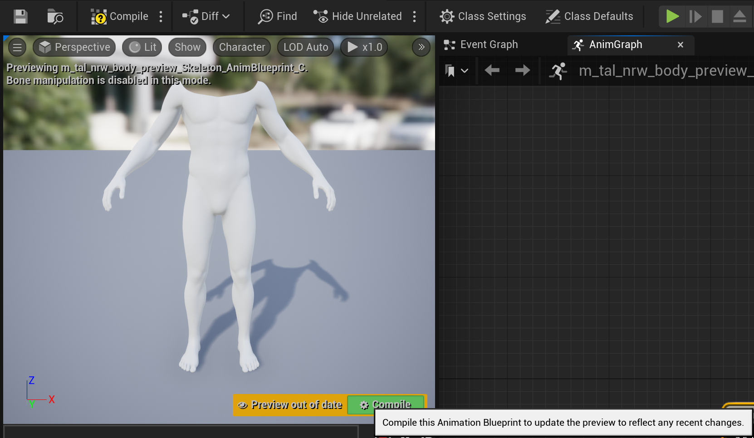

Once that is done, connect to core for the support options that are needed.

In the main screen press the connect button to connect to a local host instance of Manus Core via the dropdown box and then connect. Make sure Manus Core is running.

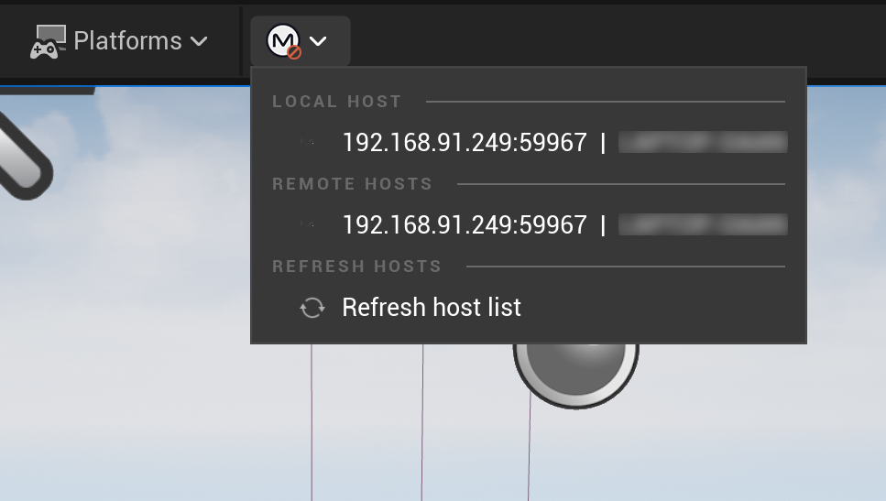

Once that is done, double click your manus skeleton.

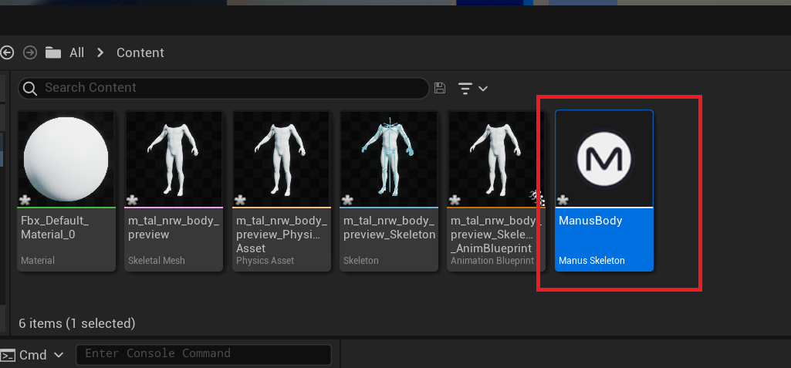

You will be presented with something similar to the following screen:

In this screen set the skeleton type to the type of animation you want from Manus Core. In this case just a hand.

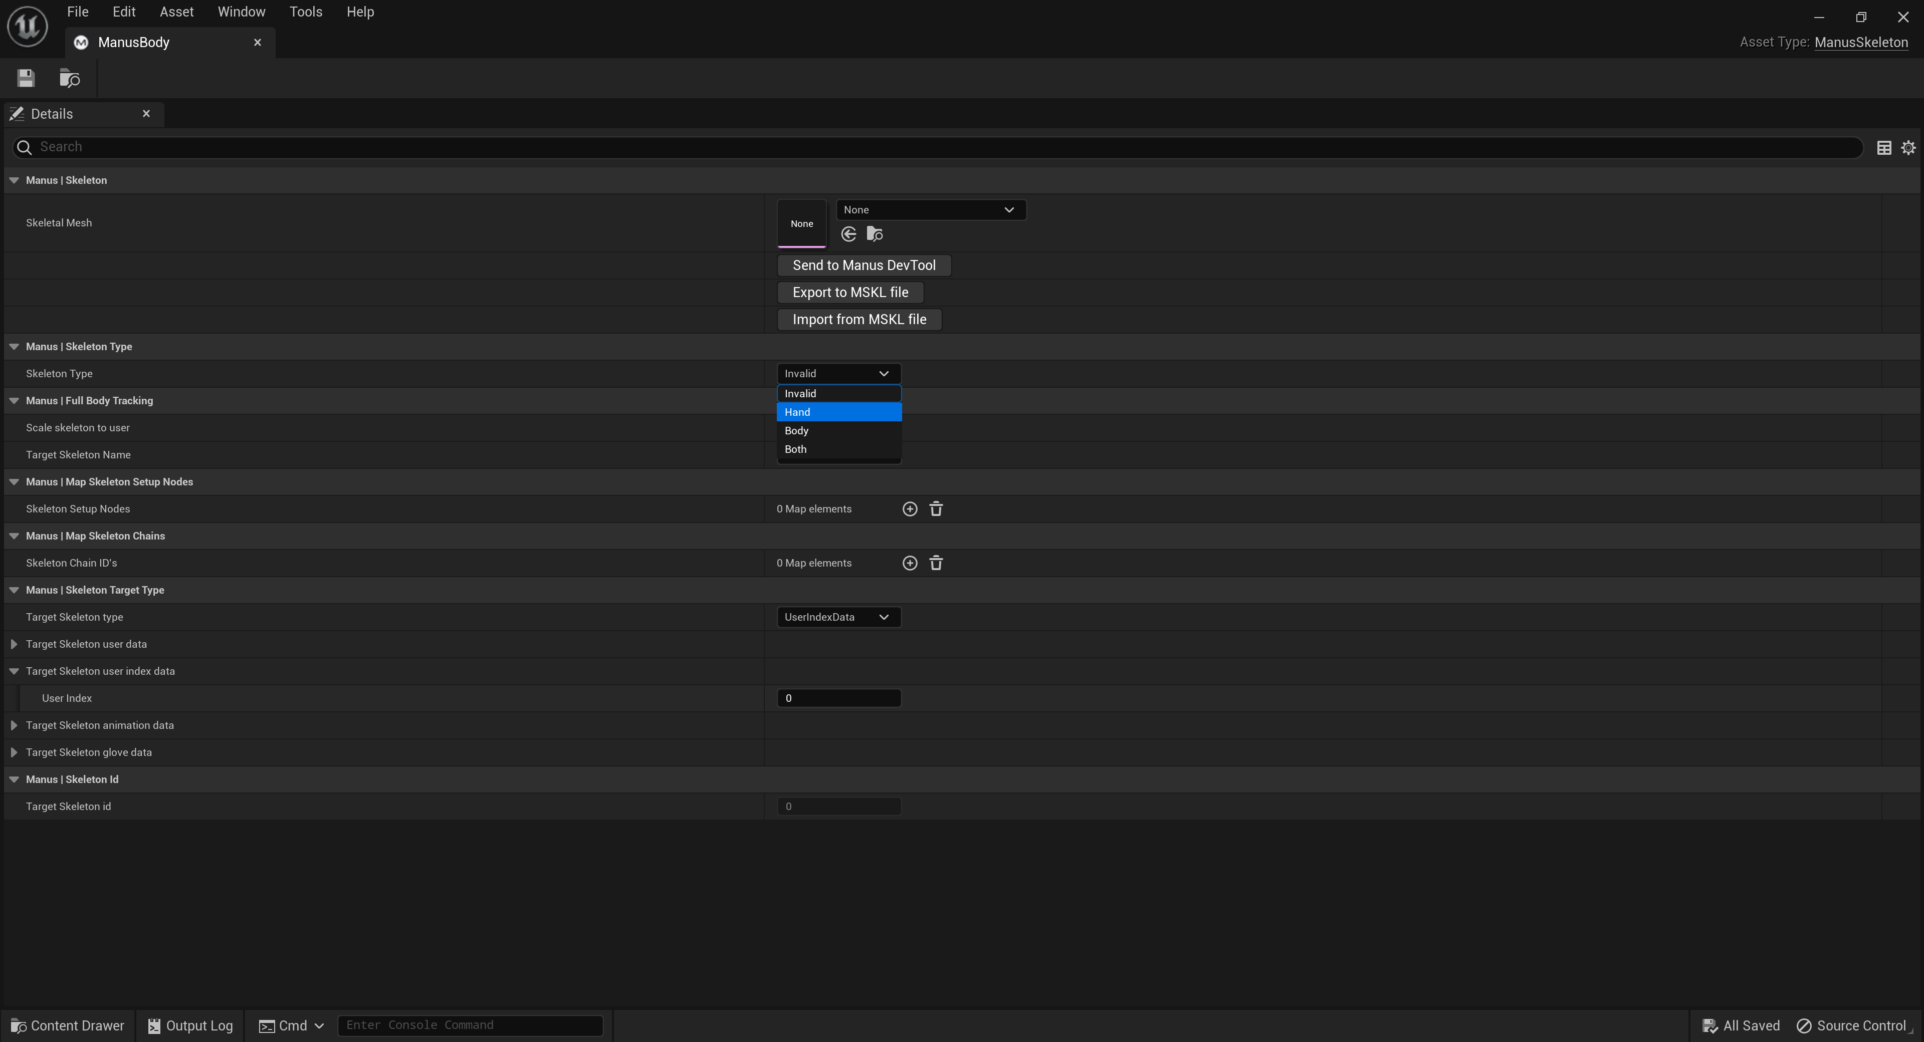

And also set the “Target Skeleton Type” to an identifier with which Manus Core can identify the animation to a skeleton. In this case “UserIndexData” is a good option.

*The user index can be left to 0 in most cases. But if you have multiple users, make sure this matches what you see in the Manus Core UI.

In the Manus Core UI user list, the top user will be index 0, and the next in the user list will be at index 1 and so on and so forth. If the incorrect index is used, then wrong or no data will be received. 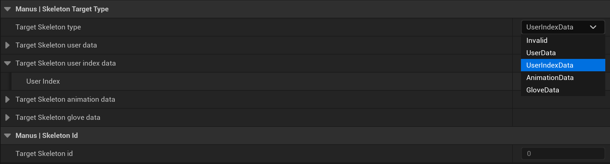

Now the mesh can be selected:

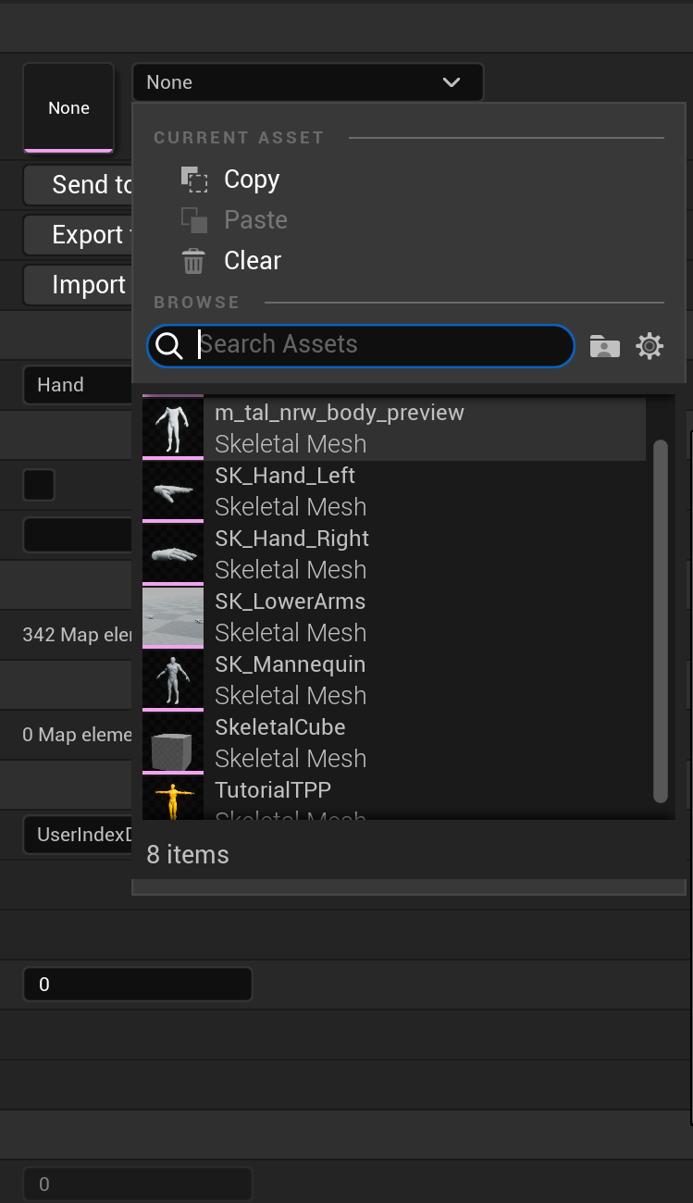

Select the mesh you imported and it will generate the nodes needed.

All that is needed, are the chains to make it possible to animate.

You can set the chains up manually, but that can be very labor intensive. For this there are 2 more options.

Either using auto allocation if it is a fairly normal model. In such case Manus core tries to find the right bones and rig them up. If it fails, you can always try again with the second option. And that is to send it to the Manus_DevTool. Also known as the Development Dashboard.

By clicking that button the skeleton is sent to the tool for editing.

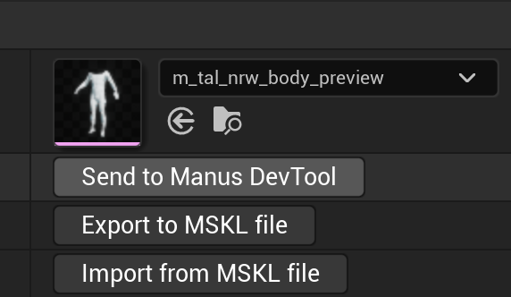

You will be presented with a screen similar to the one below:

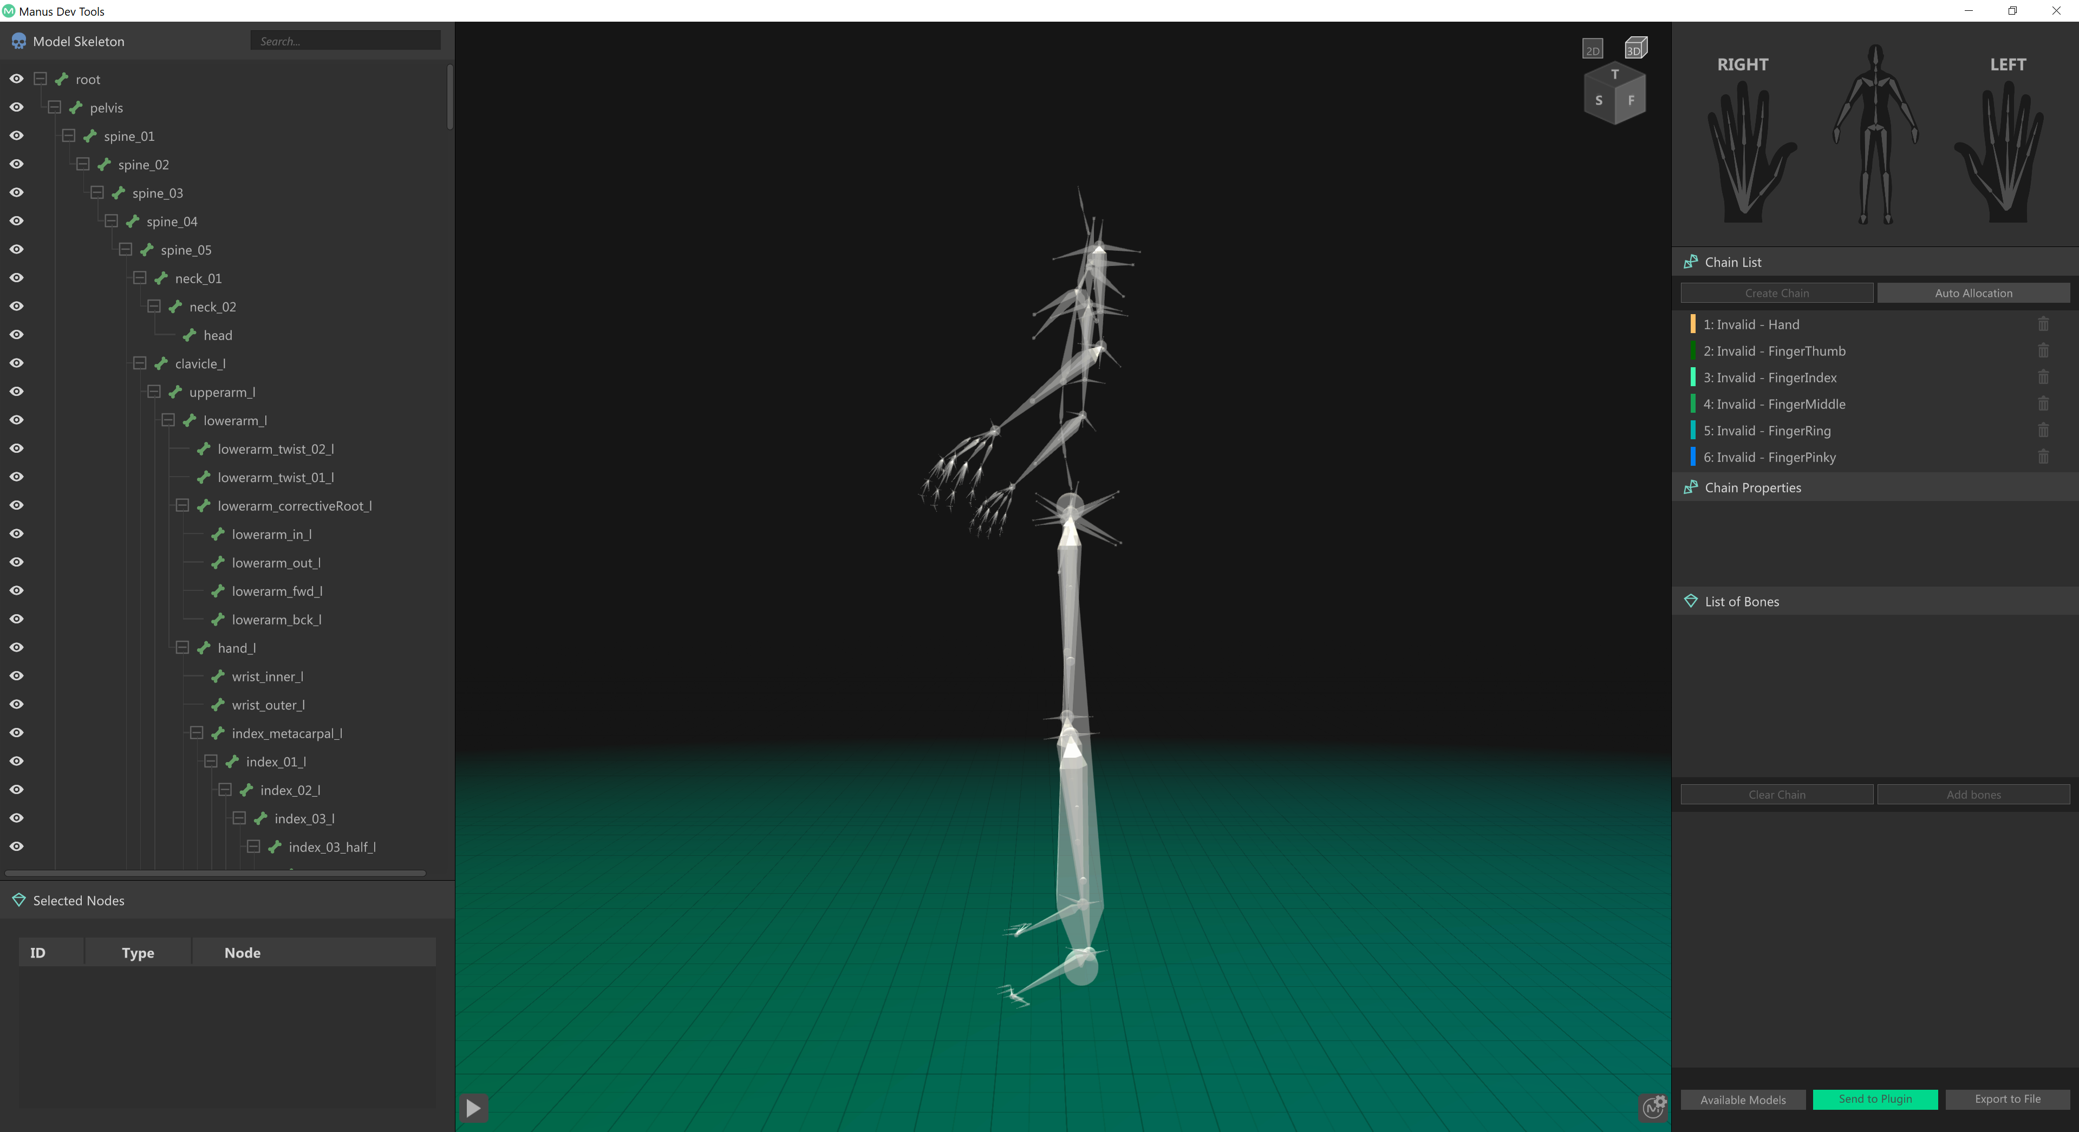

For more specific details for this tool, check the supplied documentation of the Manus DevTools.

For this example, the chains will be auto allocated and we can immediately export it back to unreal.

You can hit the ‘Send to Plugin’ button, which will send the model back to the unreal plugin.

On the Unreal side in the manus skeleton property window, verify the IMU setting has been set for the hand if you’re not using trackers.

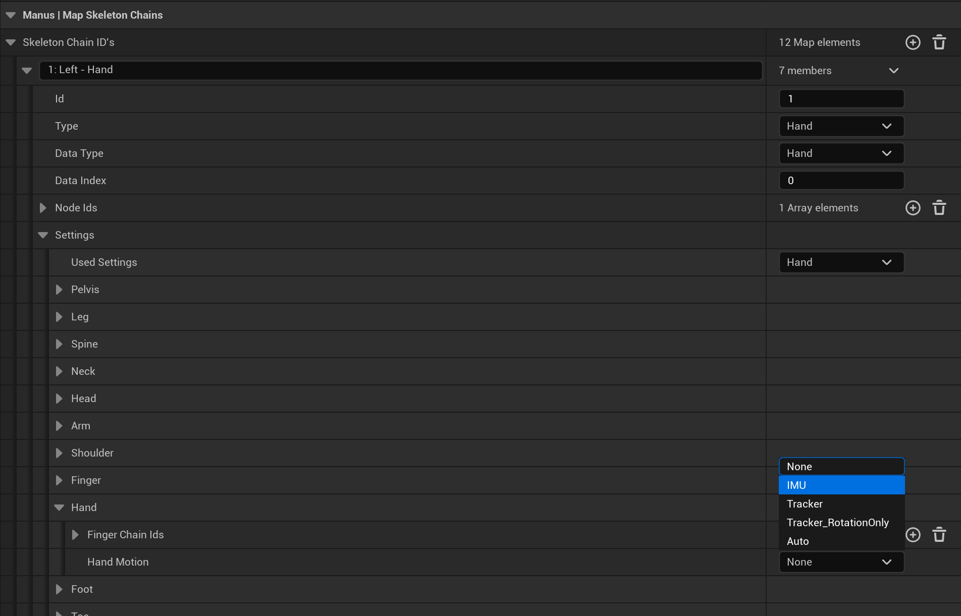

Once this is done you can see the animation being streamed from your glove directly into unreal:

In this case only the left hand was connected.

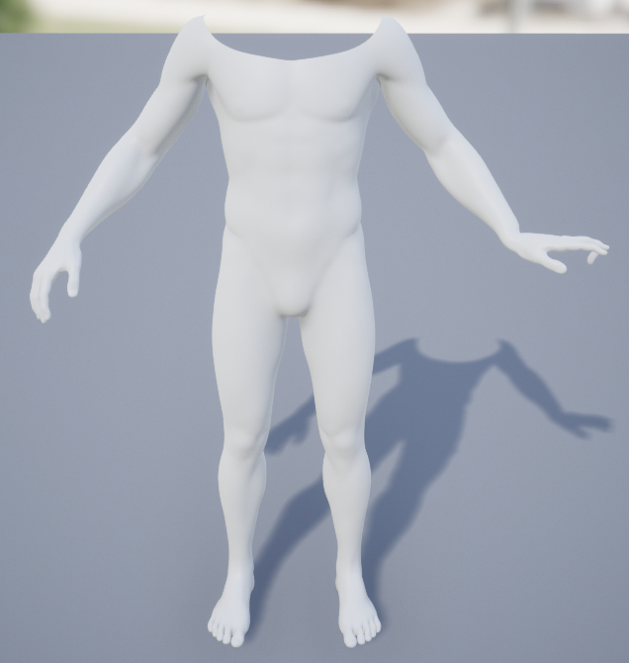

# Alternate way of setting up a model.

Similar to the previous way, there is another way of setting up a model in unreal.

First drag an actor into your level.

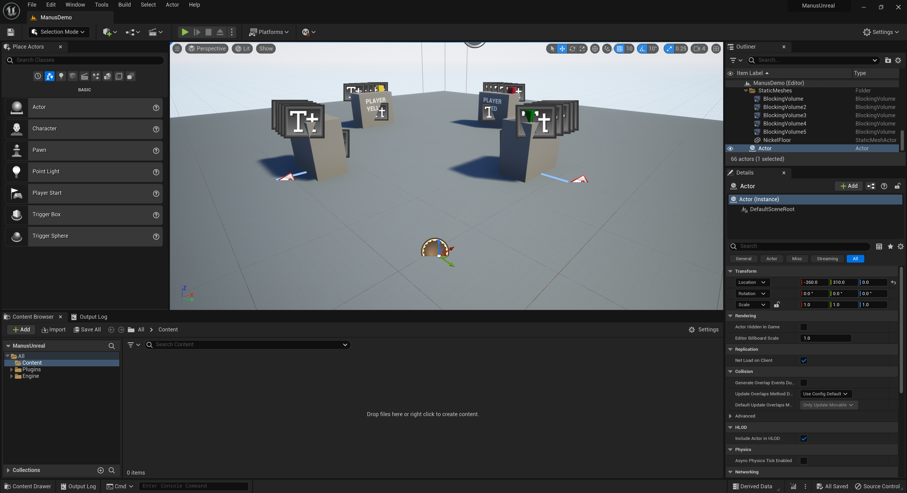

Select the actor in the sidebar and add manus link to it by pressing the add button.

A menu will appear and you can type ‘manus’ in the search bar.

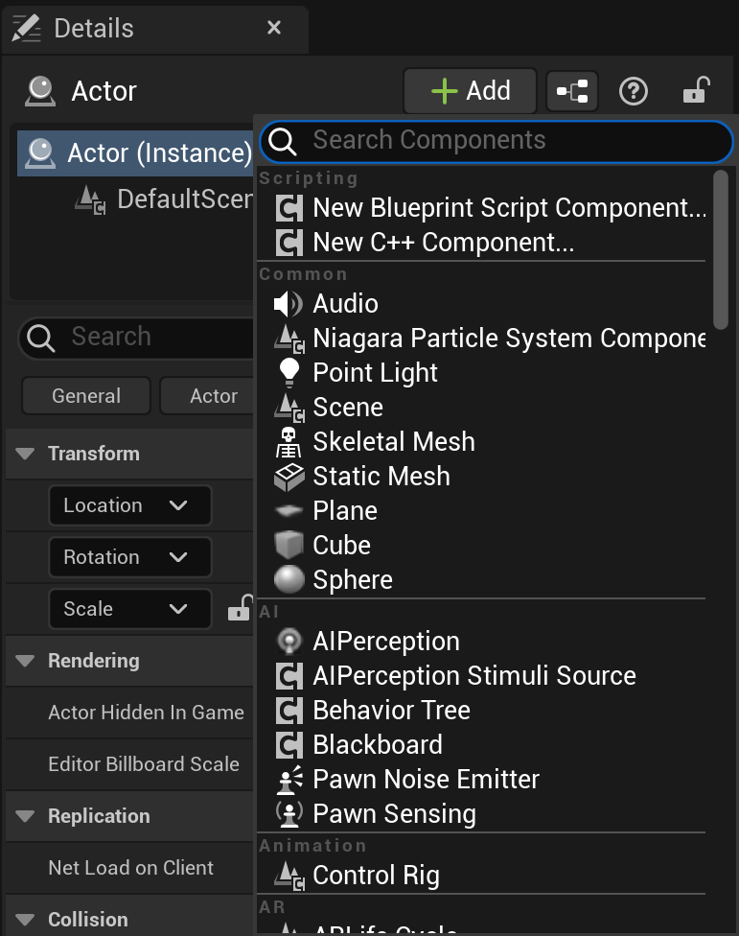

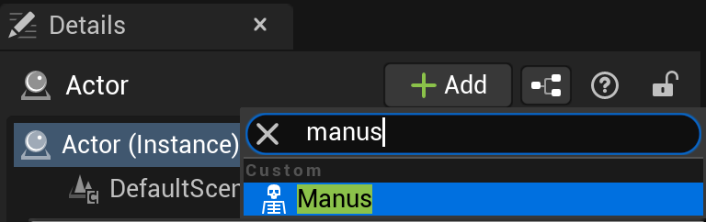

Now the Manus link is added.

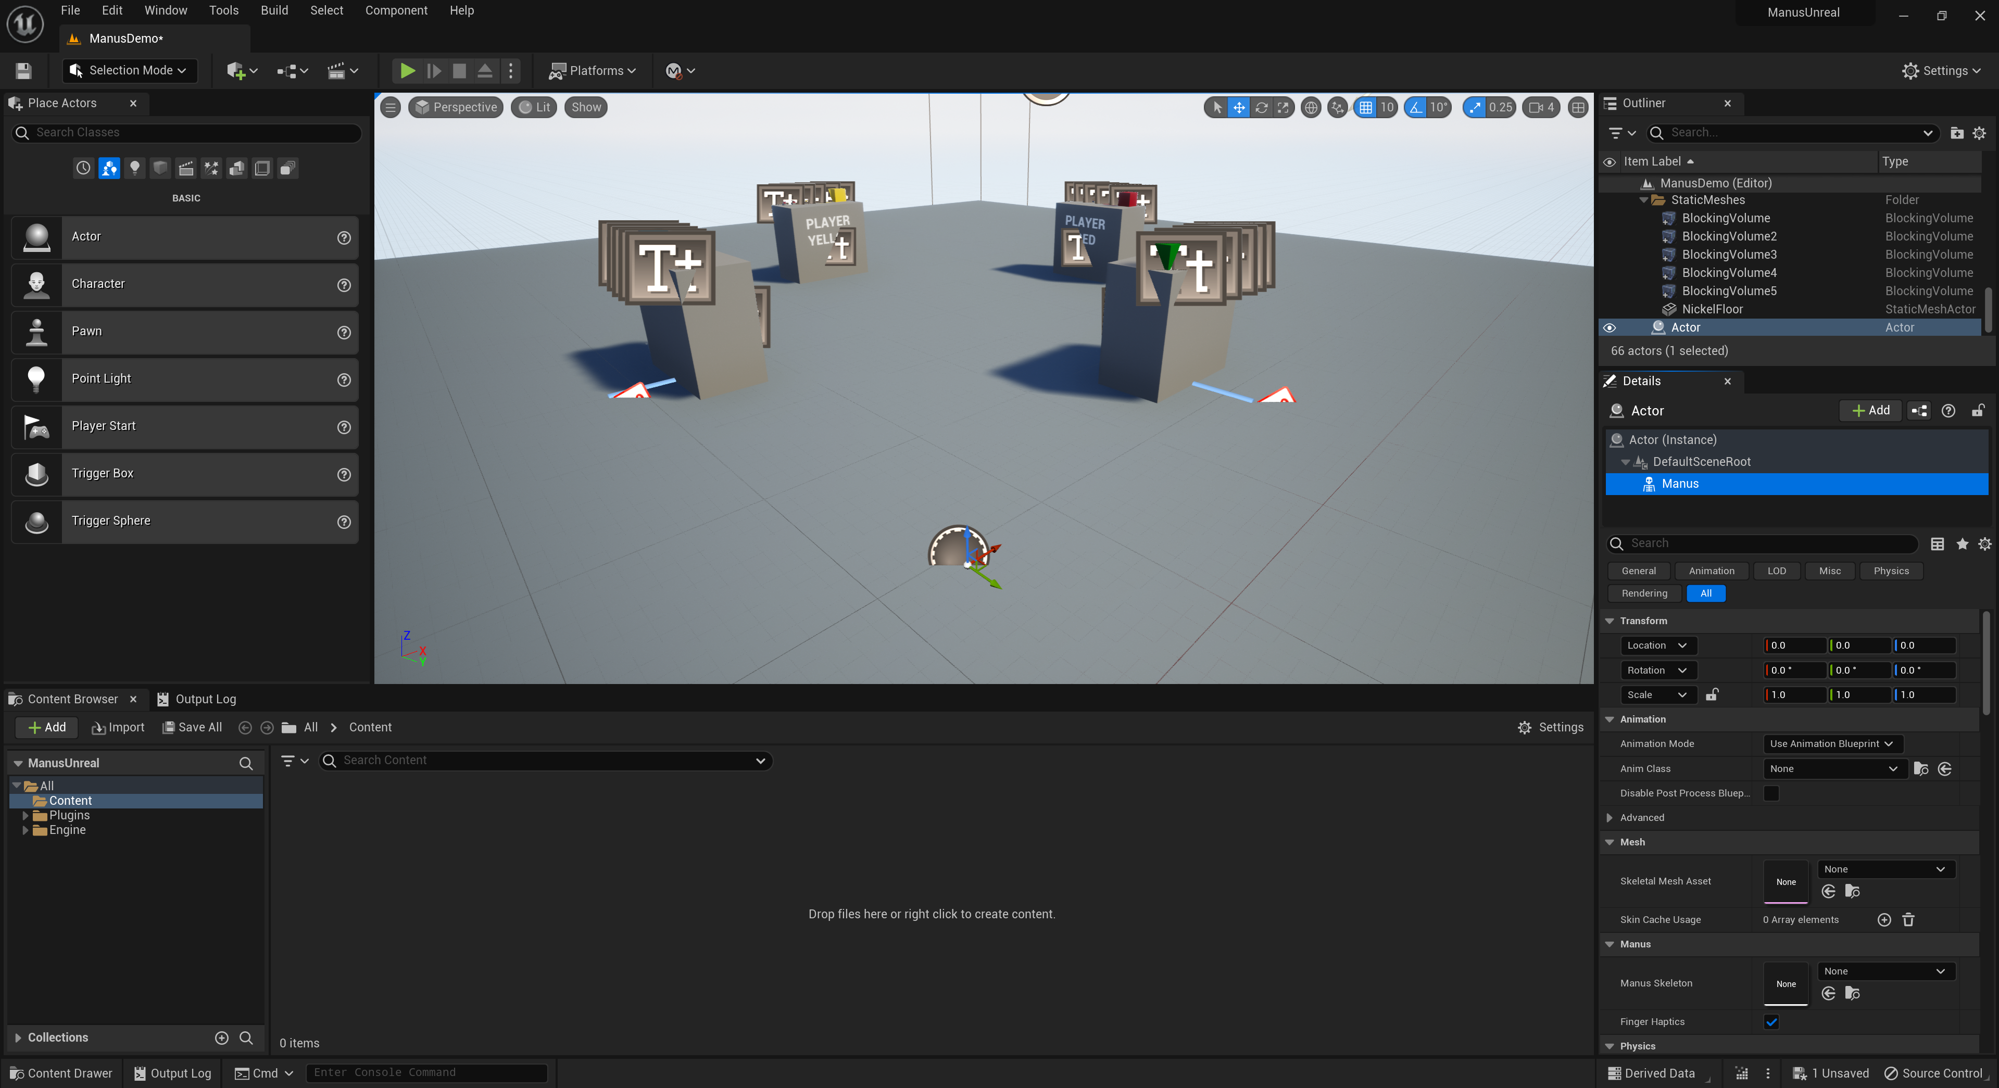

Now import your model, by right clicking the content space and select ‘import to Game’.

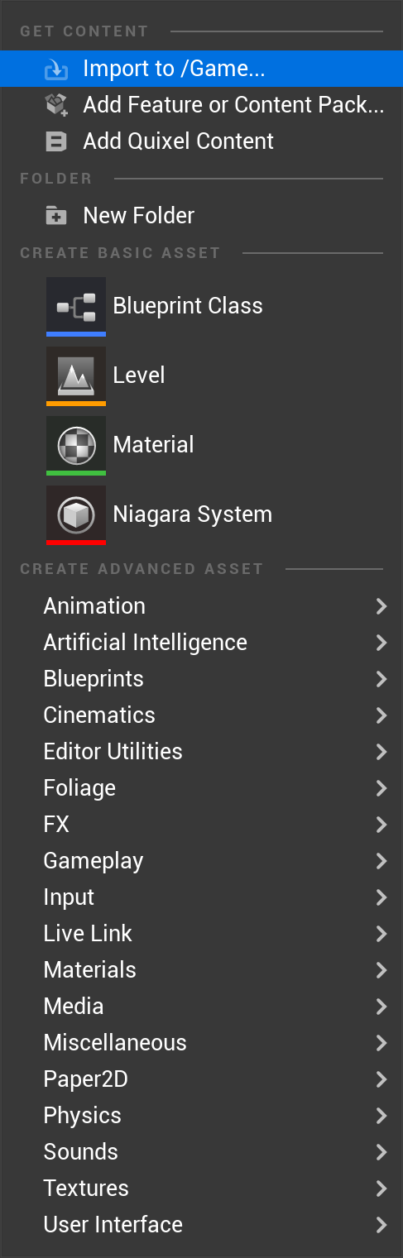

Select your model from the file browser.

Then in the next window select ‘Import’.



The meshes are now loaded.

Now Select the ‘Manus Skeleton’ Option in the right side bar of the actor and open the drop down (currently filled with ‘none’). Select ‘create a new asset ‘Manus Skeleton’.

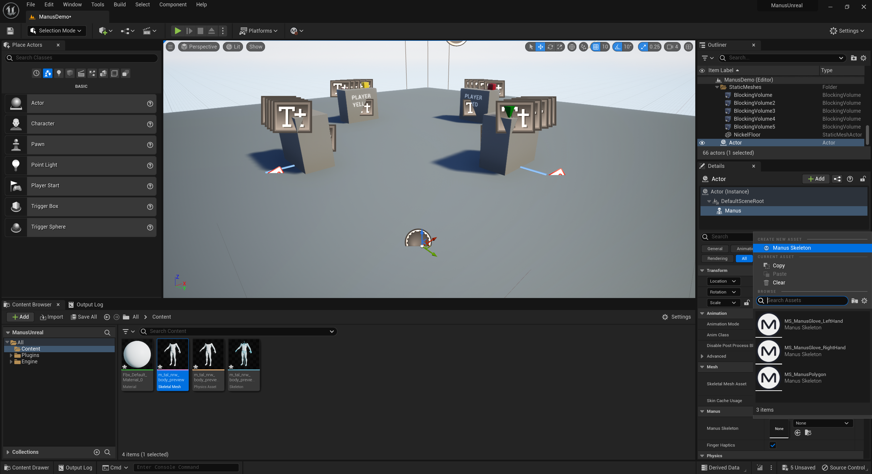

Create a new skeleton with your preferred name.

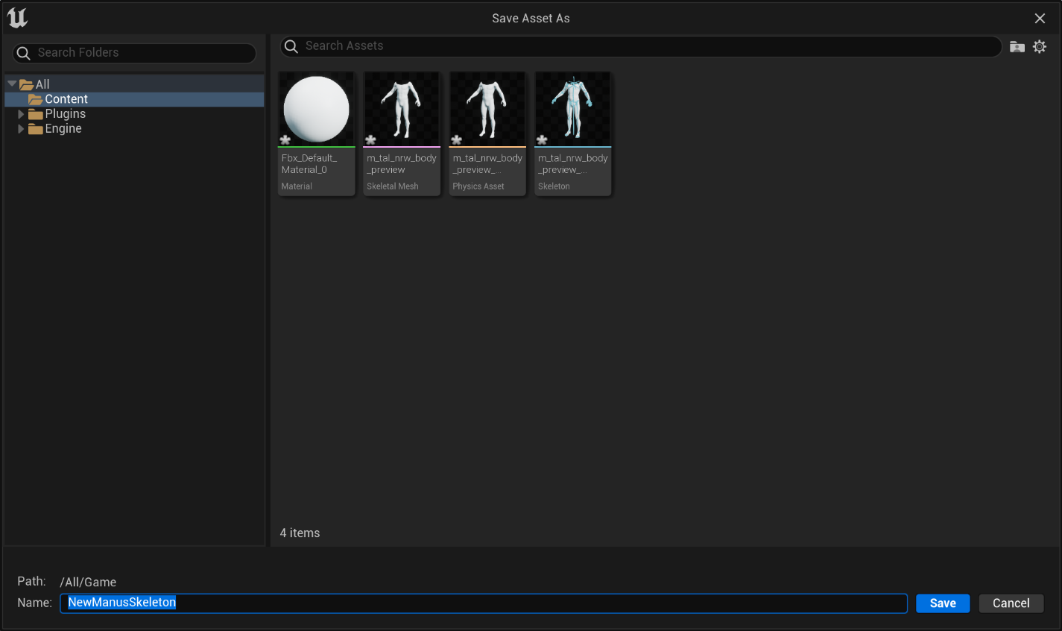

Now right click the skeleton.

And select ‘edit’. (or double click it)

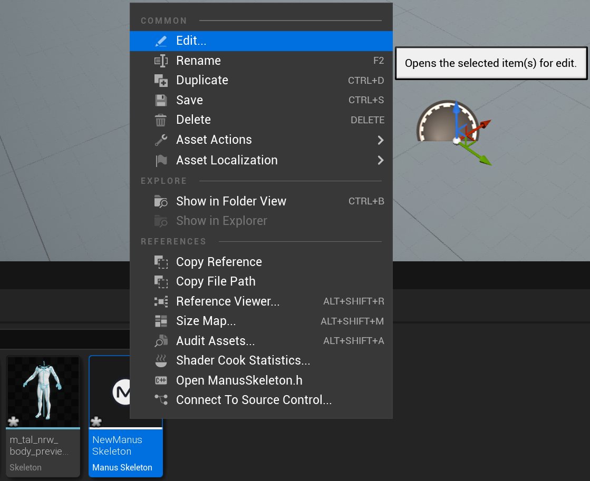

The following window opens. Select the Skeletal Mesh dropdown.

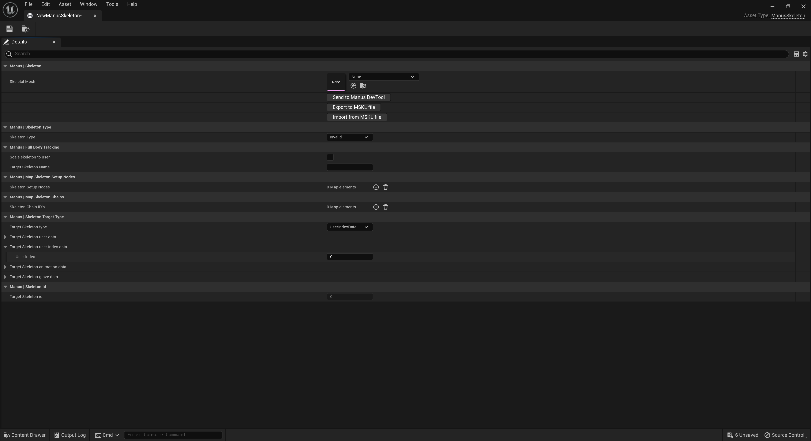

In the new menus select your mesh you imported.

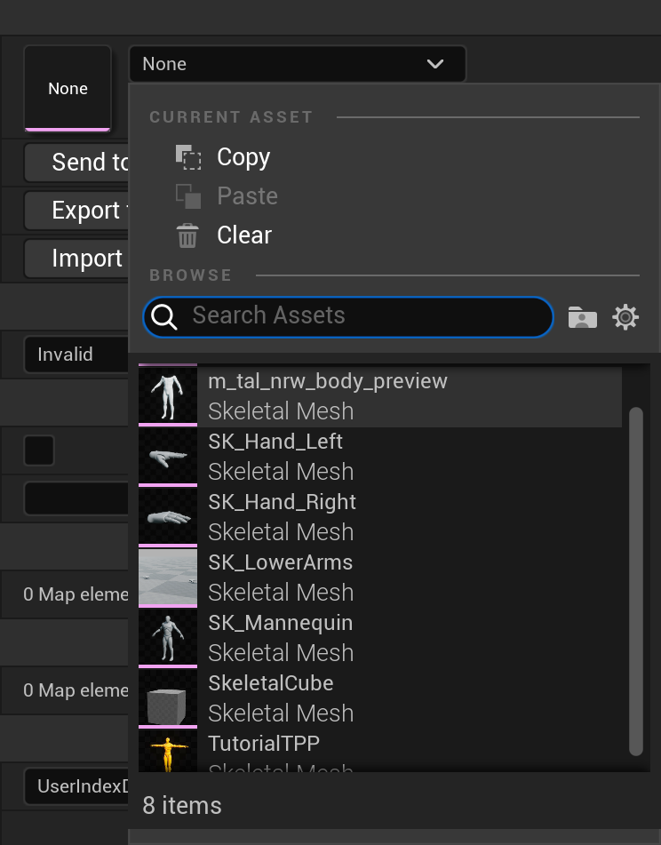

Then Select the ‘Skeleton type’ combobox and select ‘hand’ for this example.

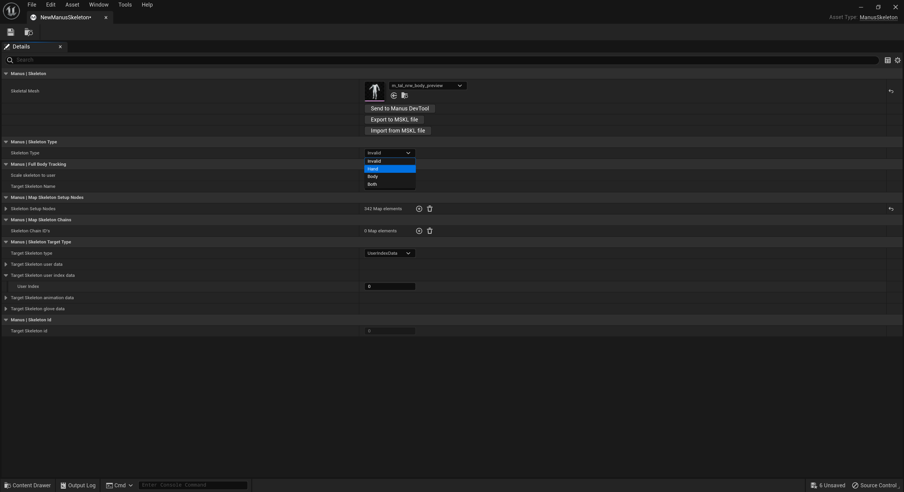

Now Press the ‘Send to Manus DevTool’ button. (make sure unreal is connected to your manus core host first though).

Just as in the previous chapter, set up the rigging of your skeleton in the Manus DevTools and when done, send it back to the unrealplugin.

Once done you will return to this screen and see the chains allocated.

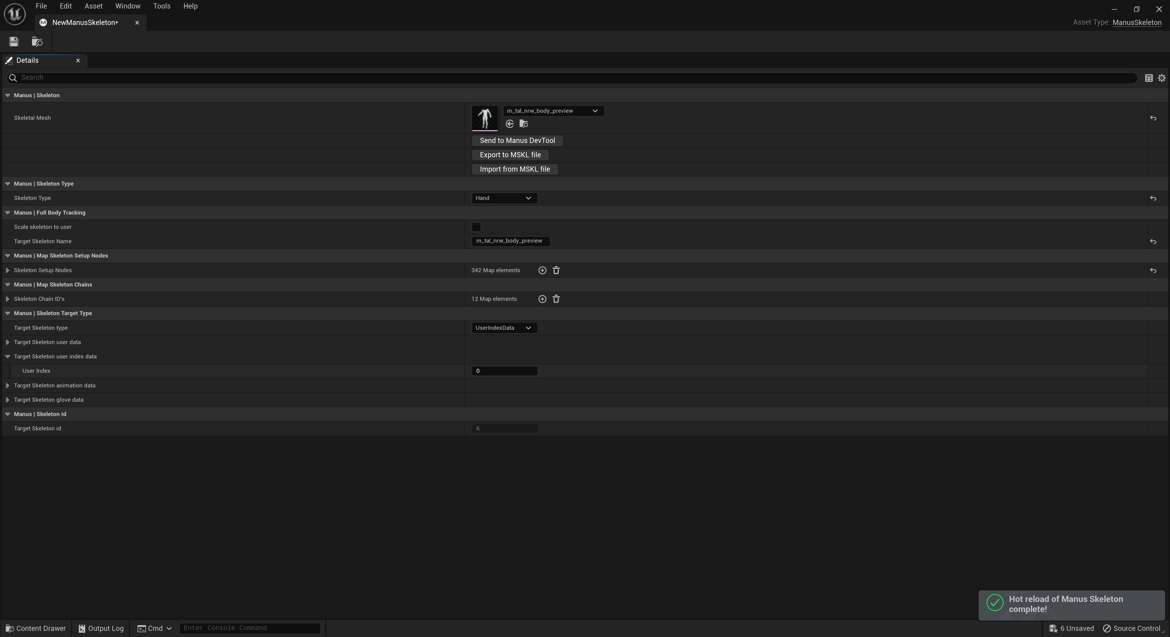

Important: Make sure the ‘Skeleton Target Type’. Make sure this matches the target selected, or no/wrong animation data will be received for this skeleton. Usually setting it to ‘UserIndexData’ and the ‘Target Skeleton user index data’ to ‘0’ will select the first user.

User indexes start counting from 0 and can be verified in the Manus Core UI.

This will match the Manus Core user list. With the top user being index 0, and the next in the user list at index 1 and so on and so forth. If the incorrect index is used, the wrong or no data will be received.

Now return to the main window and right click the mesh.

In the dropdown menu select ‘Anim Blueprint’ and create a new blueprint.

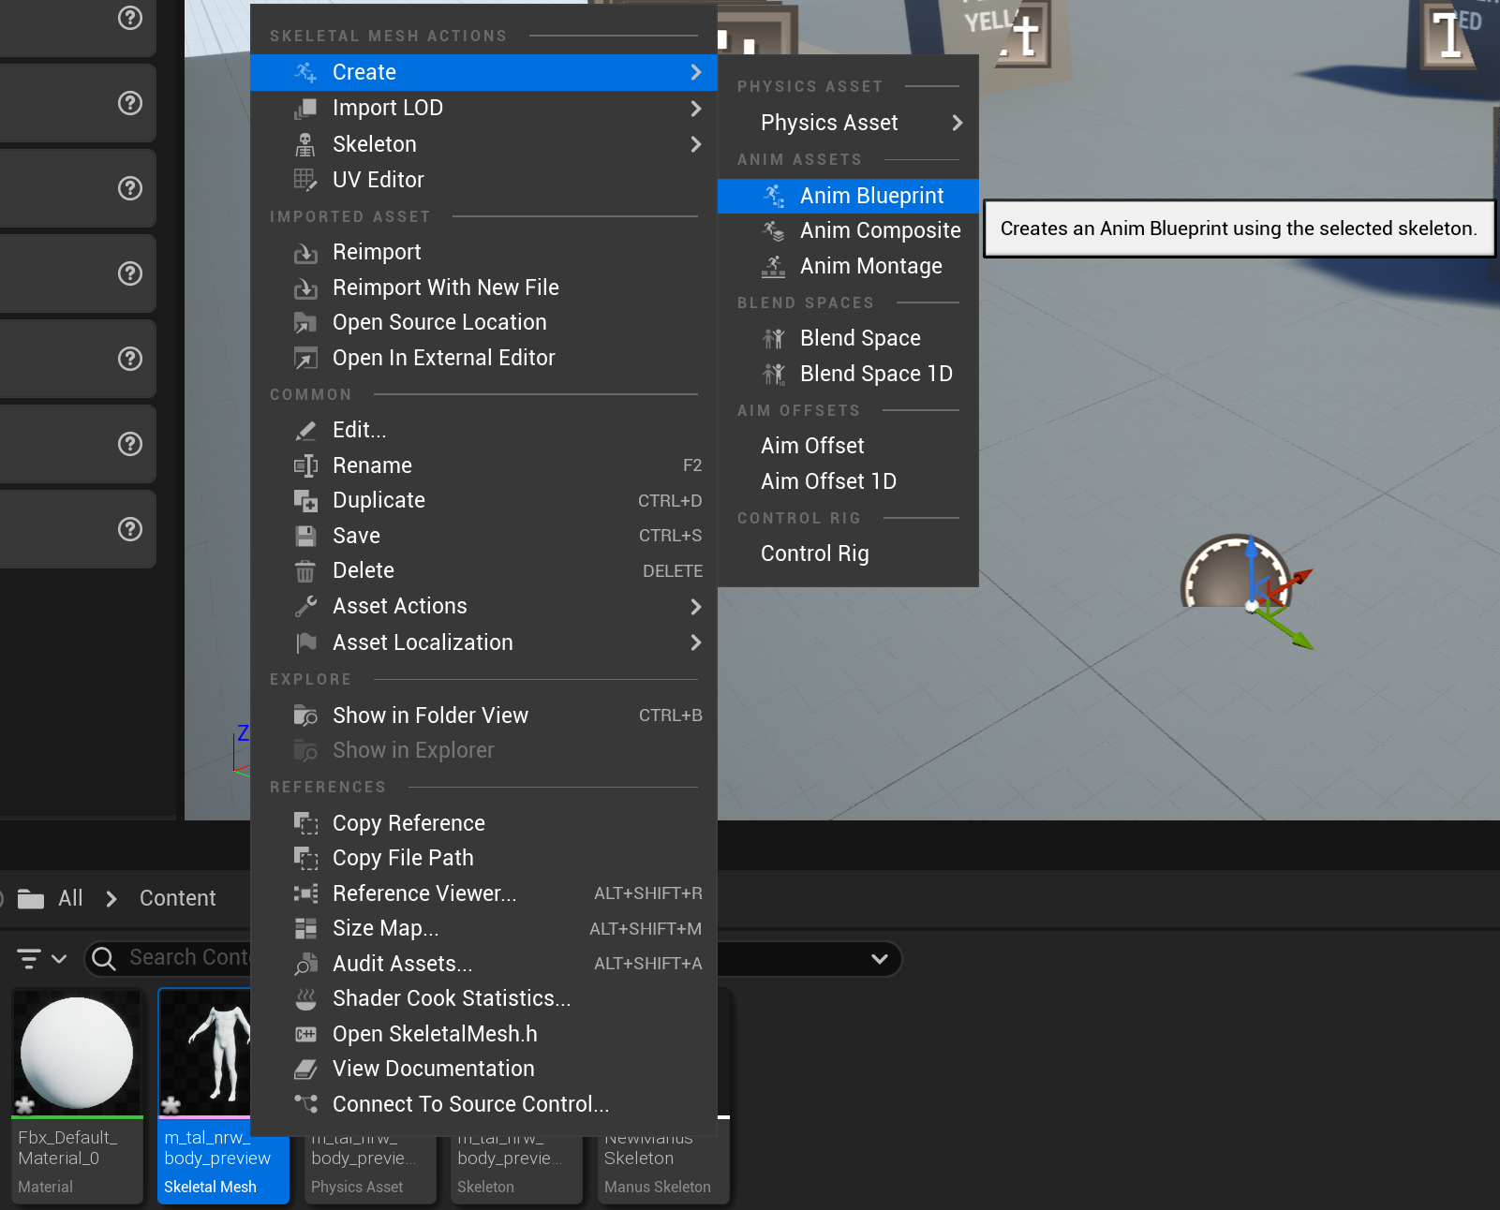

Now in the sidebar, under the actor, select an animation blueprint in the ‘anim class’.

In the dropdown menu, select the animation blueprint that was created.

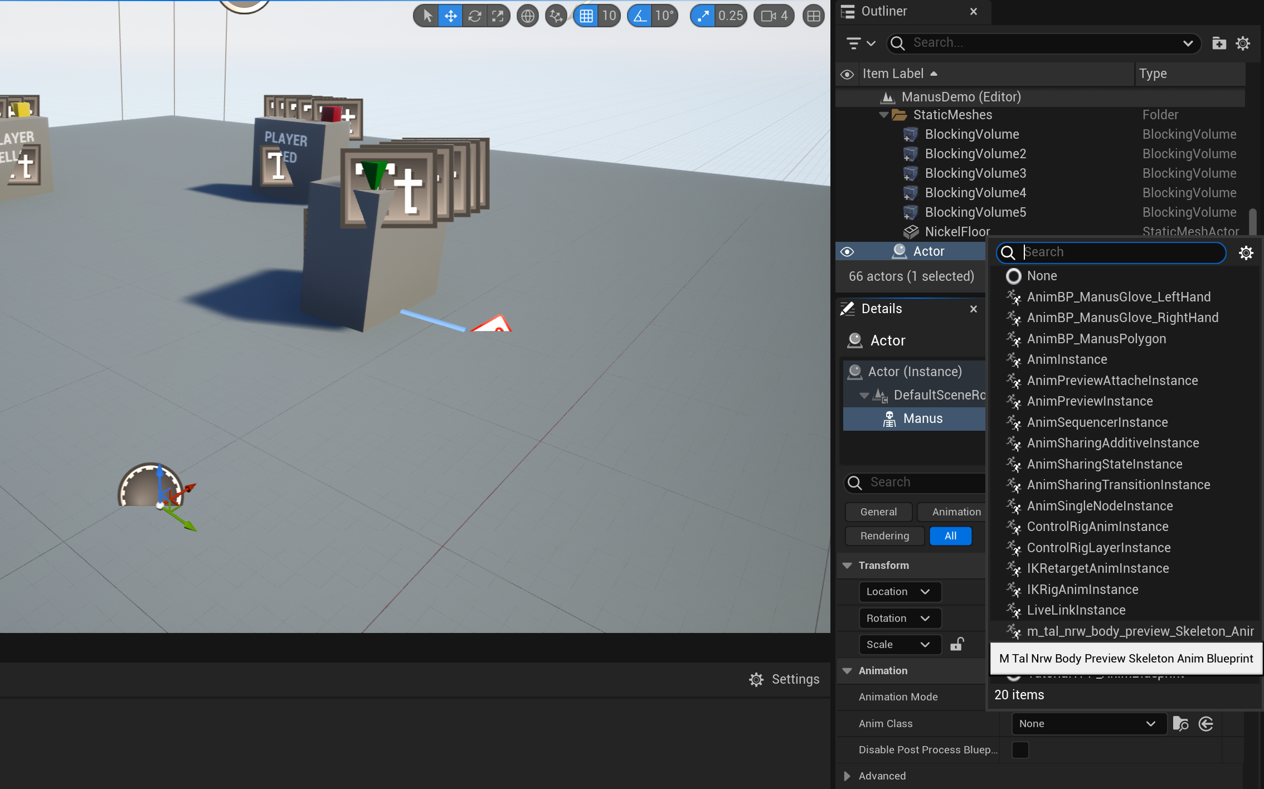

Then double click the animation blueprint that was created.

Drag the input ‘Output Pose’ into the blueprint and select ‘Manus Live Link Pose’.

Select the ‘Manus Live Link Pose’ and select the ‘Manus Skeleton’ in the right side bar. Select the skeleton previosuly created.

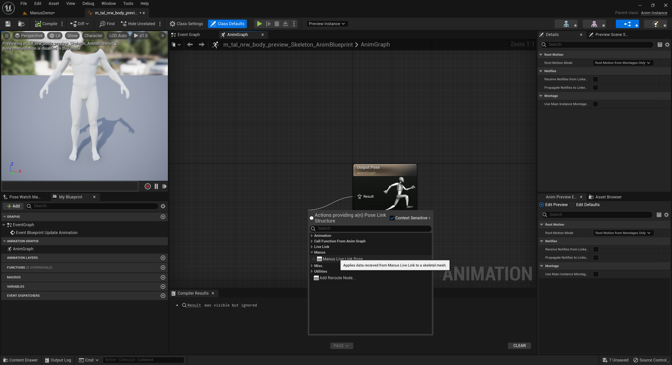

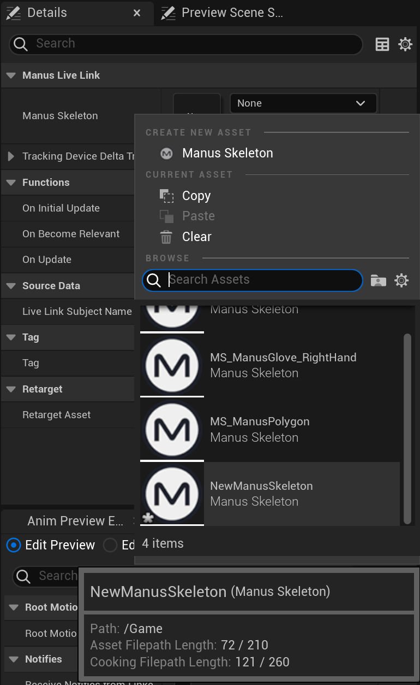

Don’t forget to compile the blueprint.



Your actor should now be fully ready to animate when in play mode.

Always make sure the skeleton is setup for the right user. And ofcourse the manus host connection is active! See the Manus skeleton section above for those settings.

# Blueprint options

For this chapter it is assumed the user is familiar with blueprints in unreal. For more details on blueprints check the online tutorials for unreal blueprints on the Unreal forums.

Several commands are available in blueprint mode and many more types are defined.

For the details on available blueprint functions, please consult the documentation.

<https://www.manus-meta.com/resources/knowledge-base-unreal>

# Blueprint setup

A good example for using the plugin, is by examining the manus demo supplied with the plugin.

However, this is specifically built for our manus demo, but can still give you good insight for your own implementation. For this we will highlight the setting up the manus connection.

# Finding manus core hosts.

To find the manus Host addresses the following blueprint can be used as example:

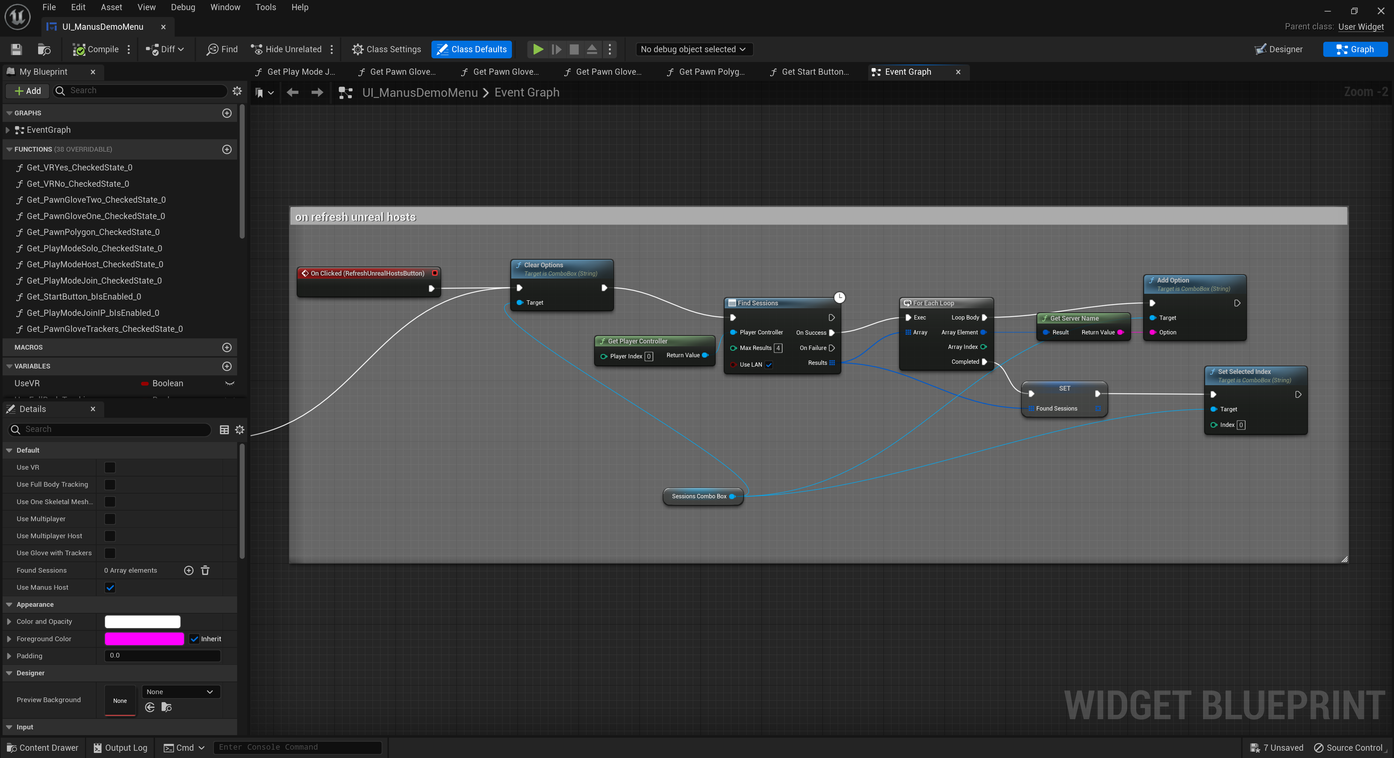

The real important function is the ‘Find Sessions’. This function will trigger the plugin to search the network for any active Manus core hosts. This can only be used if there is no current active session between the plugin and Manus core host and will take a few seconds before it responds.

Therefore, only continue with the blueprint upon success of this function. It will return an array of addresses found and can work with multiple network interfaces as the same time.

It is best to store these, so they can be used later when connecting to a Manus core host.

# Blueprint making a connection

Opening up the UI_ManusDemoMenu>EventGraph presentation of the blueprint will show the following image when focused ‘On start’:

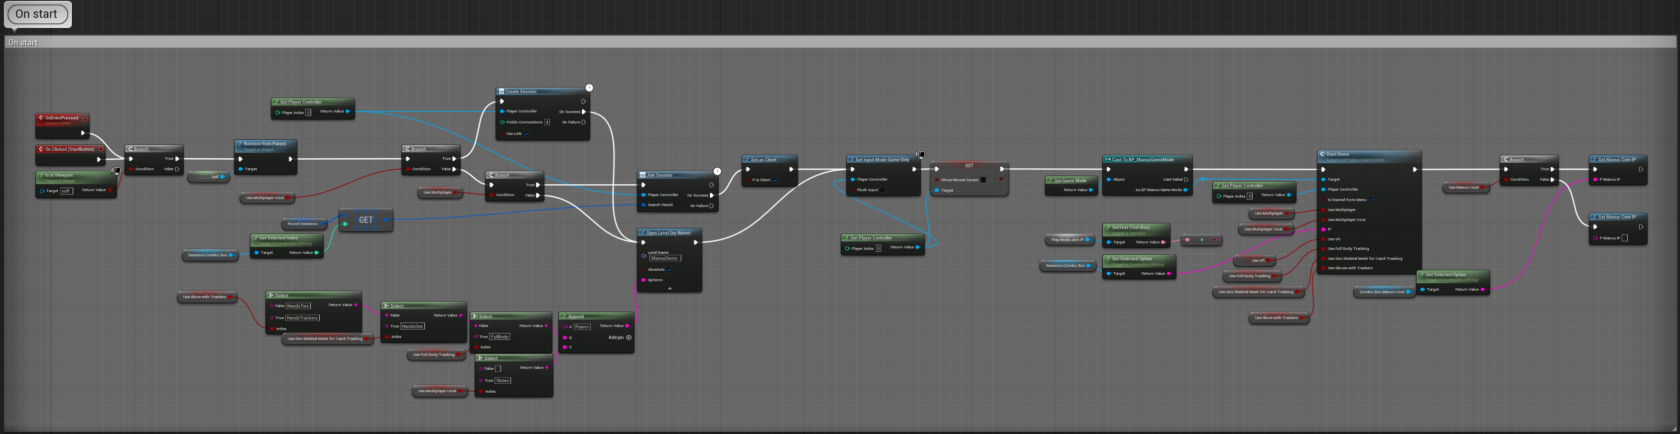

Which at first glance may look a bit daunting, but 2 main parts are important.

First, the environment the example is using. (Single player, multiplayer host, multiplayer client)

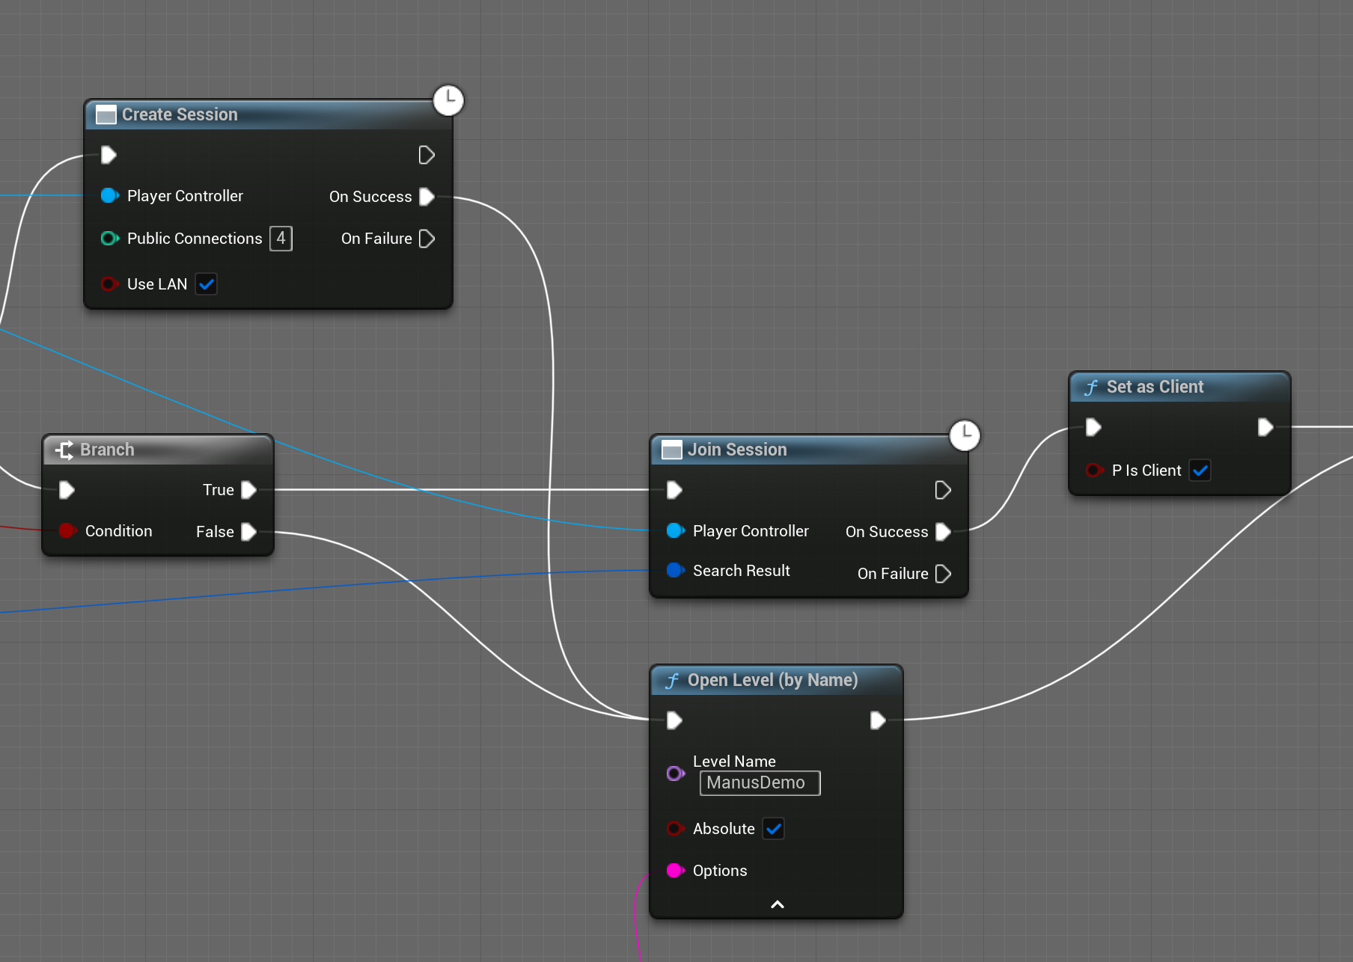

This follows the standard unreal network environment setup, so for more details on that, check the unreal forums and documentation.

In case it is single player it will call the ‘Open Level’ function directly.

If it is the host of a multiplayer environment, it will create a session and then open the level.

But if it is a client it will only ‘Join Session’ and signal to the plugin it is ‘Set as Client’.

Level loading will then be handled by ‘Join Session’.

Setting it as client is important for replicating everything correctly in a networked environment.

Secondly, once everything is done, we need to signal the plugin what Manus Core Host address to use.

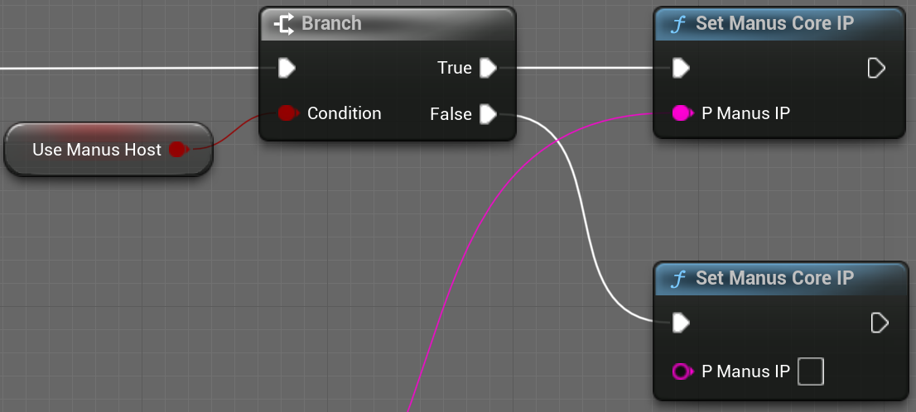

If the environment is setup as the host, the supplied address from the host selection can be input into the ‘Set Manus Core IP’. If no address is set it can receive data only via replication.

The addresses always must be found first via the ‘Find Sessions’ function, or it will not accept the address.